# **Williams Middle School**

# **PE Uniforms 2024 –2025**

**Ordering Windows**

**8/07/2024 - 8/22/2024**

**8/23/2024 - 9/07/2024**

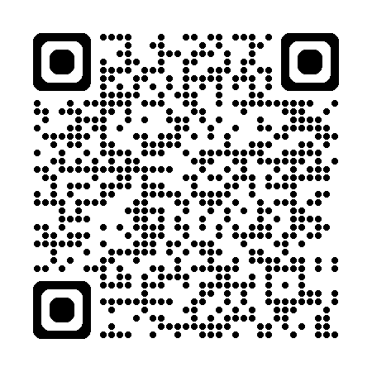

https://williamspeuniforms.itemorder.com/shop/sale/